TASK-2
LINKDIN
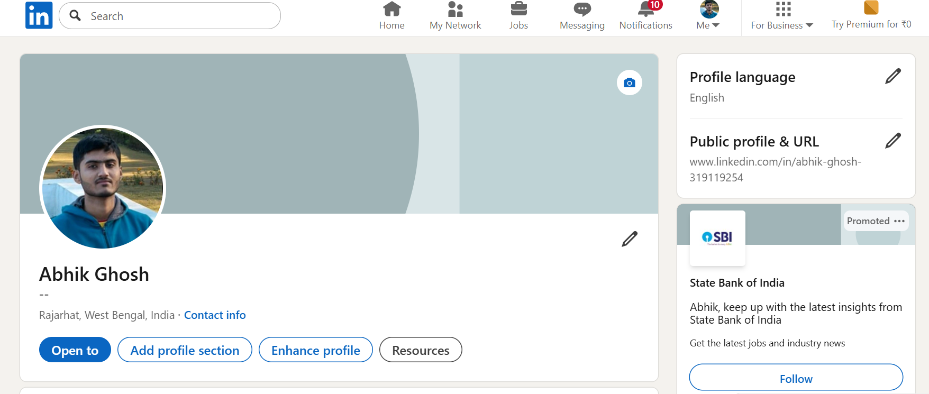
VISIT LINKDIN

GITHUB
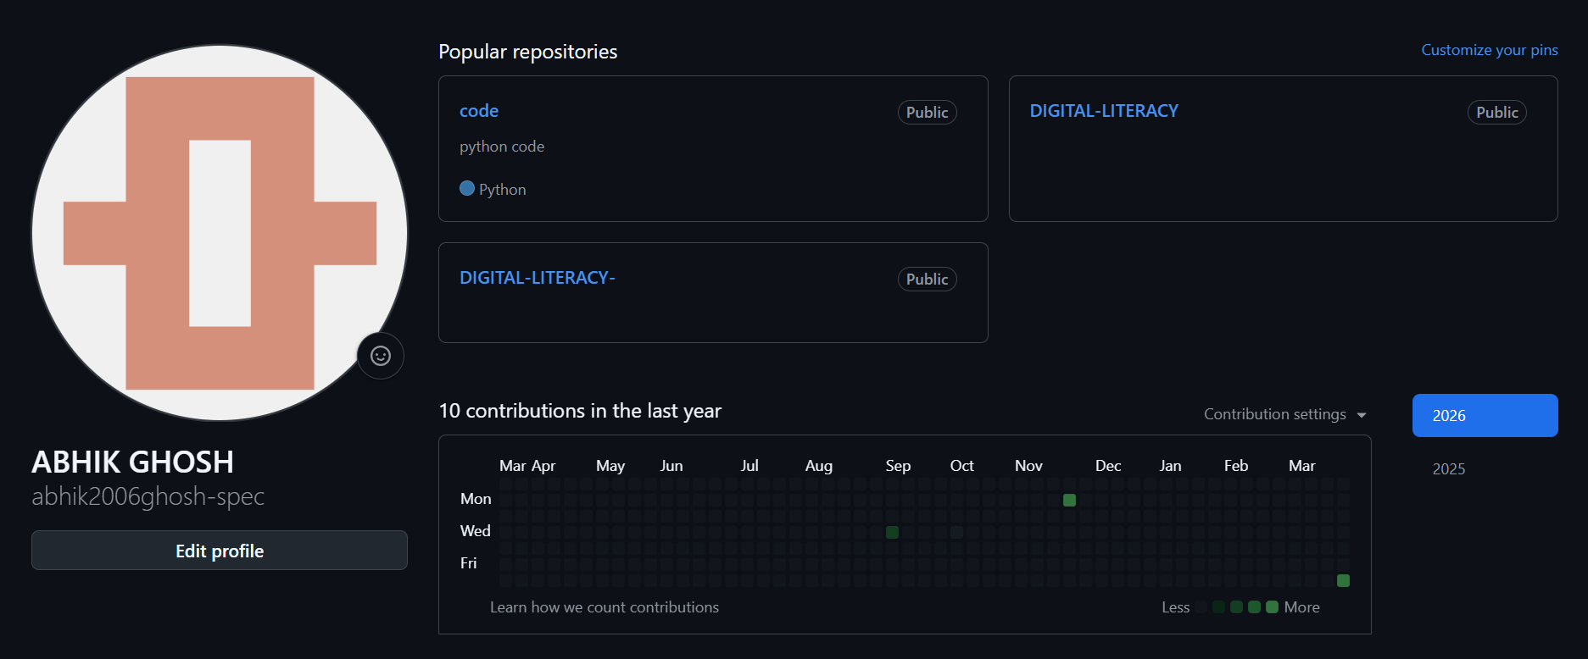
LINK GITHUB

KAGGAL
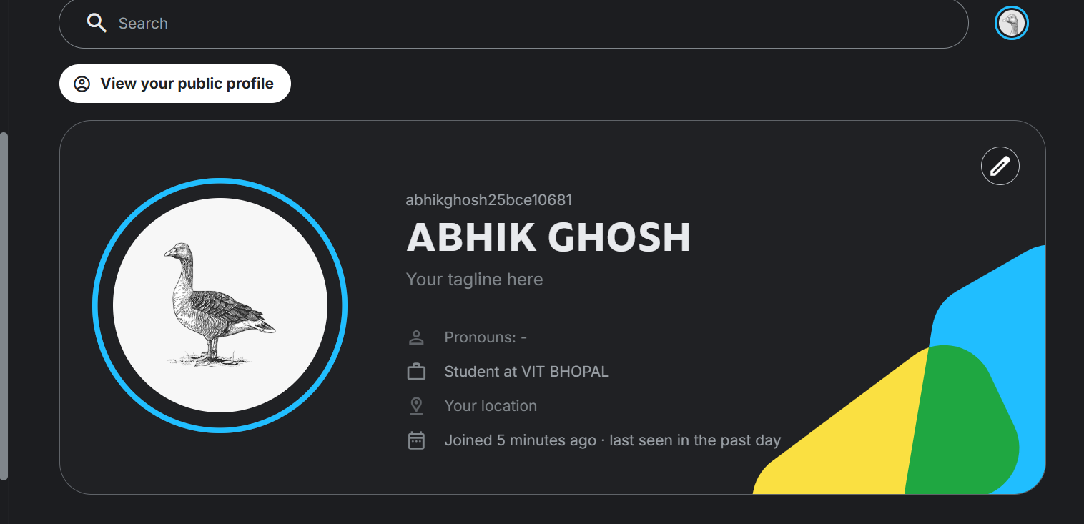
LINK KAGGLE

HACKER RANK
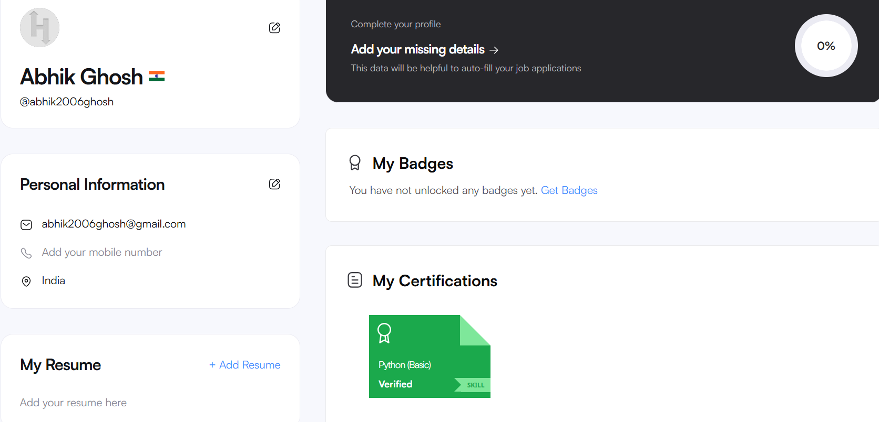
LINK HACKERRANK

